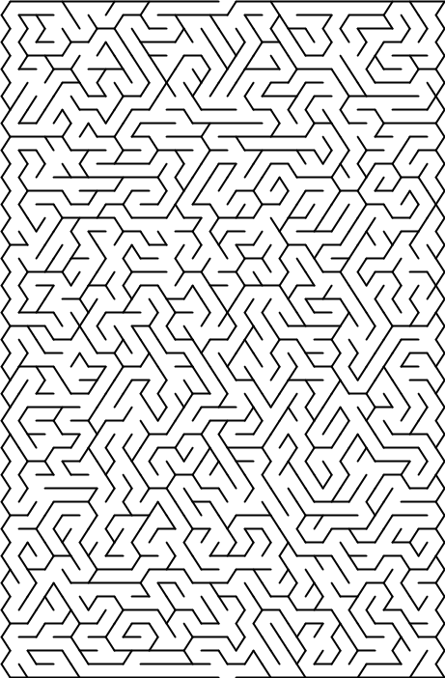Start at “purpose” and end at “conclusion”. You will travel through the steps of the scientific method to get to the finish.



Image result for procedure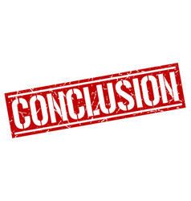

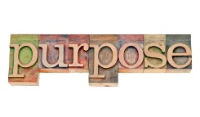

Image result for hypothesis

Image result for background information