Sounds Like Music Lab
Objective
Understand the difference between sound and music
Understand how we can control what frequency an object vibrates at

Background
Sound exists everywhere in the world. Typically objects cause waves of pressure in the air, which are perceived by people as sound. When an object is struck, it can vibrate with a certain frequency. The particular sound the object makes when struck is a direct result of the frequency at which it vibrates. A good example is hitting a glass bottle that has water in it.
Among the sounds that exist in everyday life, a few produce a definite pitch, such as blowing air over half-full glass bottles, tapping a glass with a spoon, and tapping long steel rods against a hard surface. This is because a certain component of the object vibrates in a periodic fashion.
Certain things can affect the frequency at which an object vibrates. With a guitar string, the string tension, thickness and length all affect the frequency. Anything that makes the object vibrate faster increases the frequency and thus increases the pitch that an object produces. Thus, the pitch produced by an object can be changed by the length or the volume of the portion that vibrates. For example, by gradually filling a bottle while blowing across the top, higher pitches can be generated. By organizing a few of these sounds with a clearer pitch, the sounds become closer to music.
The very first musical instruments involved using various objects (such as bells) that have different pitches, played in sequence. These sounds with particular vibrations can be organized and played in a pleasing order to make music. The water-filled glass bottles provide evidence of this as simple songs can be learned on the bottles. This method of sound manipulation is the basis for many instruments, which demonstrates how sound and music correlate.
Since the first instruments, the ability to control pitch has greatly improved as illustrated by more modern instruments such as guitars, violins, pianos and more. Music is comprised of organized sound, which is made of specific frequencies. The organization of the pitches is what transforms sounds into music.

Materials
- Water
- 8 pieces of glassware (circle the one your group used) – small beakers, medium beakers, Erlenmeyer flasks
- Glass rod

Procedure
- Fill your glassware with varying levels of water.
- Try to get different pitches or tones out of your glassware when struck lightly by the glass rod.
- Organize your glassware from lowest pitch to highest pitch.
- Play a simple song on your “instrument” (i.e. Mary Had a Little Lamb, Jingle Bells, Twinkle Twinkle)
- Draw your setup with approximate water levels.
- On your drawing, number the glassware from 1-8 (1 = lowest pitch, 8 = highest pitch).
- Write out the number order of your song.

Data/Drawing

Notes for Song (Number Order)

Analysis
- How is sound different from music?

- How can we control what frequency an object vibrates at?

- What caused the change in pitch from glassware to glassware?

- What changes when you strike the glassware strongly vs. softly?

- A guitar string was plucked multiple times by applying different levels of force to the string. The energy and amplitude of each “pluck” was recorded in the chart below.
Plot the data from the chart on the graph.
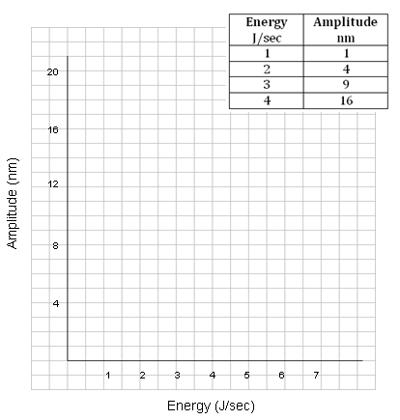
How can you represent the relationship between energy and amplitude with a mathematical statement? (Fill in the blank.)
Energy is proportional to the ____________ root of amplitude.
Using E for energy and A for amplitude, write your statement as a mathematical expression.
______________________________________________________________________________

