Waves
Wave = ______________________________________________________________
1) Mechanical Waves – _________________ (or medium) to transfer energy
    - A medium is the substance through which a wave can travel. Ex. Air; water; particles; strings; solids; liquids; gases
2) Electromagnetic Waves – ____________________ (or medium) to transfer energy
    - They do not need a medium, but they can go through matter (medium), such as air, water, and glass
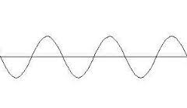
Mechanical Waves can be transverse and/or compression (longitudinal)
1) Transverse = Energy causes the matter in the medium to _______________________________ ______________________________________ at right angles to the direction the wave travels

crest = _______ point
trough = _______ point
wavelength = distance between crests
amplitude = the peak (greatest) value (either positive or negative) of a wave. The larger the
amplitude, the greater the energy
frequency = number of wavelengths that pass a point in 1 sec
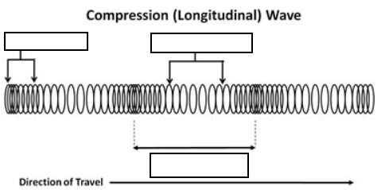
2) Compression (longitudinal) = matter in the medium moves forward and backward along the same direction that the wave travels.
compression = part of wave where
particles are __________________
rarefaction = part of wave where
particles are __________________

